Student Assessment Submission and Declaration
When submitting evidence for assessment, each student must sign a declaration confirming that the work is their own.
Student name: ADEL SHURAB / 21023153 |  | Assessor name:  Lana Issa
Issue date (1St Submission):  10/4/2023 | Submission date (1St Submission):  31/5/2023 |  | Submitted on:
In case of resubmission
Issue date (1St Submission):  7/6/2023 | Submission date (1St Submission):  10/6/2023 |  | Submitted on:
Programme: Higher National Diploma in computing- Intelligent systems
Assignment number and title: 1: Understand and build analytical models

MILESTONE1

Q1:

examples of where GYC can use predictive and prescriptive models in their work:

1-Customer segmentation: GYC can use predictive models to segment customers based on their likelihood to buy a car or to default on a loan. This can help the company tailor their marketing messages and offers to each segment more effectively

2-Loan risk assessment: GYC can use predictive models to assess the risk of default on a loan for each customer. This can help the company make more informed decisions on whether to approve a loan and at what interest rate.

3-Inventory optimization: GYC can use prescriptive models to optimize their inventory by recommending which car models to stock based on customer demand and preferences. This can help the company avoid stockouts and reduce inventory costs.

4-Pricing optimization: GYC can use prescriptive models to optimize their pricing strategy by recommending the optimal price for each car model based on market demand and competition. This can help the company increase its profitability and market share.

Q2:
METHOD | INPUT | PROCESS | OUTBUT | TOOL
Descriptive Modeling: Principal Component Analysis (PCA) | Customer data, such as occupation, monthly income, credit score, years of employment, financial status, finance history, number of children | Reduce the dimensionality of the data and identify underlying patterns or structures | Reduced set of variables that capture the most important information about customers | R, Python, SAS
Predictive Modeling: Support Vector Machine (SVM) | Customer data, such as occupation, monthly income, credit score, years of employment, financial status, finance history, number of children | Build a model that classifies customers into different groups based on their input variables | Classification of customers into groups based on their likelihood to buy a car | R, Python, MATLAB
Predictive Modeling: Neural Network | Customer data, such as occupation, monthly income, credit score, years of employment, financial status, finance history, number of children | Build a model that learns complex relationships between input variables and an outcome, such as a customer buying a car | Probability of a customer buying a car, based on their input variables | R, Python, MATLAB, TensorFlow

Q3:

explain the types of models and the differences between descriptive, predictive, and prescriptive models.

Descriptive models: These models aim to describe and summarize the data in a way that helps us understand it better. Descriptive models are often used in exploratory data analysis to identify patterns and trends in the data. The primary goal of descriptive models is to gain insights into what has happened in the past or what is currently happening. For example, a descriptive model could be used to analyze customer data and identify demographic trends or customer preferences. The main advantage of descriptive models is that they can provide valuable insights into the data. However, descriptive models are limited in their ability to make predictions or inform future actions.

Predictive models: These models aim to predict future outcomes based on historical data. Predictive models use statistical techniques and machine learning algorithms to analyze historical data and identify patterns that can be used to make predictions about future events. For example, a predictive model could be used to predict which customers are most likely to buy a car based on their past behavior and demographic information. The main advantage of predictive models is that they can help businesses make informed decisions and develop effective strategies. However, predictive models are limited by the quality of the historical data and the accuracy of the algorithms used.

Prescriptive models: These models aim to identify the best course of action to achieve a specific goal. Prescriptive models use optimization techniques and decision-making algorithms to analyze data and identify the best course of action based on specific criteria or constraints. For example, a prescriptive model could be used to identify the best marketing strategy to increase car sales based on customer demographics and budget constraints. The main advantage of prescriptive models is that they can help businesses optimize their operations and achieve specific goals. However, prescriptive models are limited by the complexity of the decision-making process and the accuracy of the algorithms used.

Q4:
Using analytical models can provide several benefits to a business, including:

1-Improved decision-making: Analytical models can provide businesses with insights into customer behavior, market trends, and other factors that can help them make more informed decisions.

2-Increased efficiency: By using analytical models to optimize operations, businesses can increase efficiency and reduce costs.

3-Better customer targeting: Analytical models can help businesses identify the most profitable customers and target them with personalized marketing campaigns.

4-Increased revenue: By optimizing operations and targeting the most profitable customers, businesses can increase revenue and profitability.

MILESTONE2
Q1:
File bi
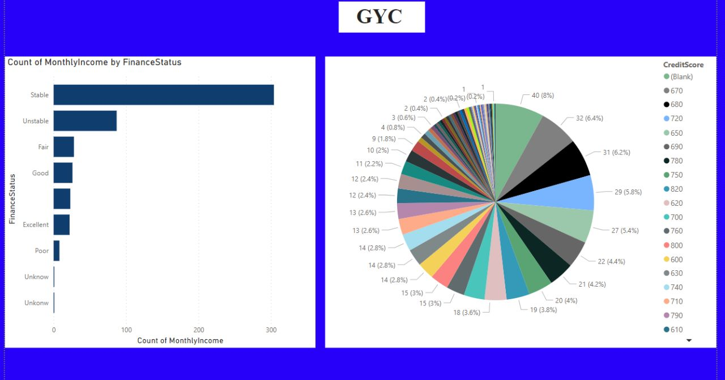
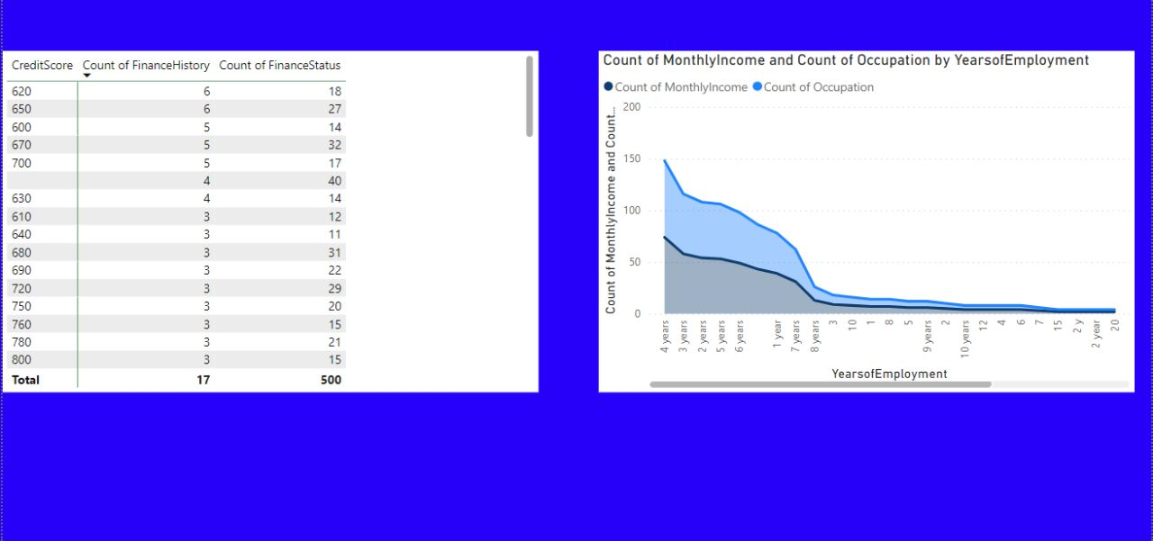
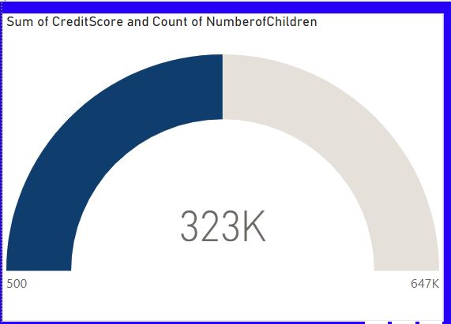
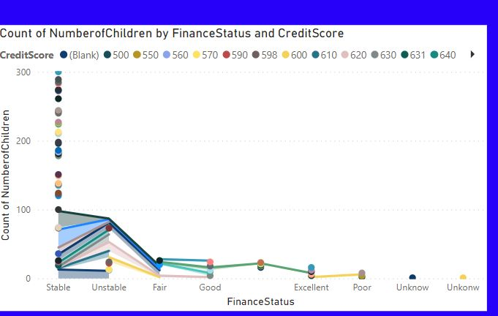
Q2:
Data preparation is a critical phase in any data-driven project as it ensures the accuracy and consistency of the data that will be used for analysis. Data cleaning is one of the most important activities in data preparation, as it involves removing inconsistencies, errors, and missing values. It is important to ensure that the data is accurate and consistent to avoid any biases or errors in the analysis process. Data discretization is another important activity that involves transforming continuous variables into discrete categories, making it easier to analyze the data. Data aggregation is another key activity that involves combining data from multiple sources to create a more comprehensive dataset. This helps ensure that the data is complete and ready for analysis. Finally, data reduction involves reducing the amount of data by removing redundant or irrelevant features, which can improve the performance of analytical models and save time and resources.in the end, data preparation plays a crucial role in ensuring that data-driven projects are successful by providing high-quality, standardized, and reliable data for analysis.
Q3:
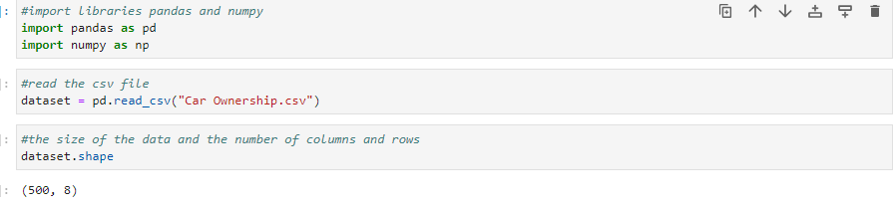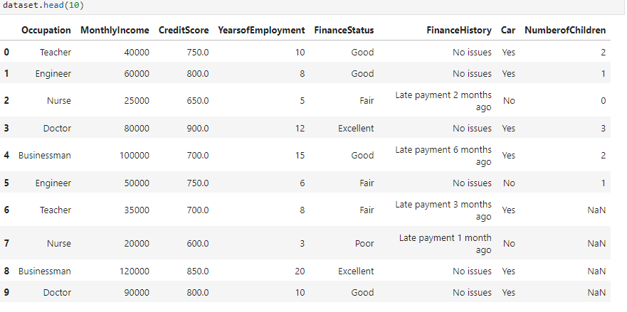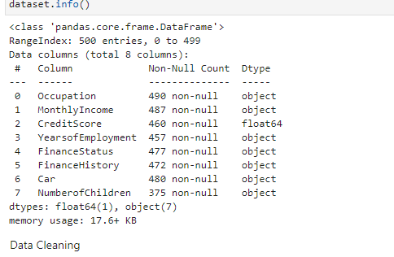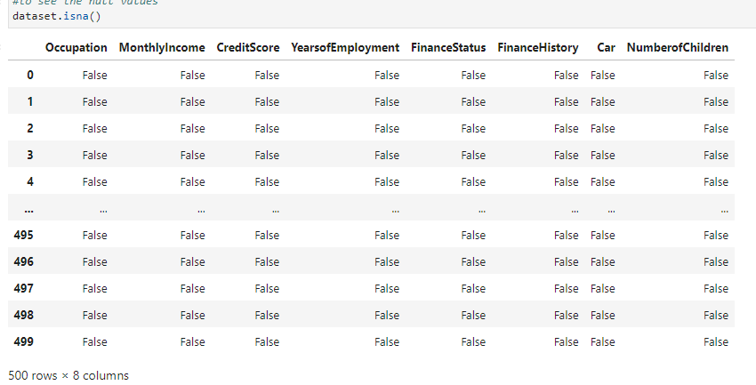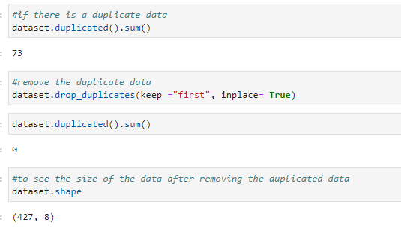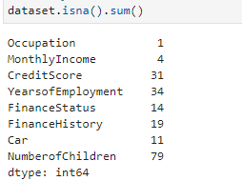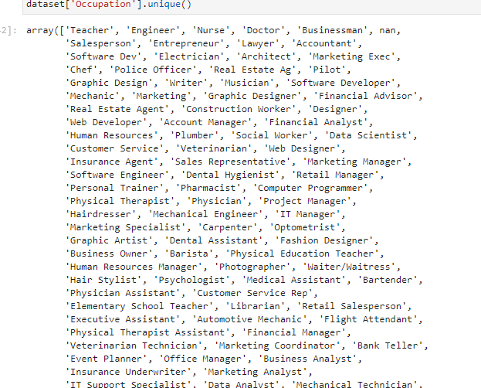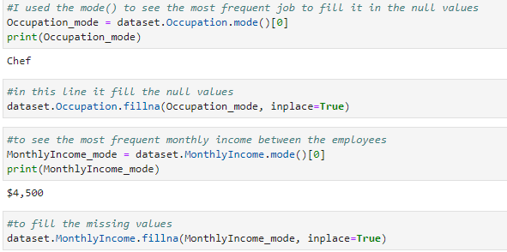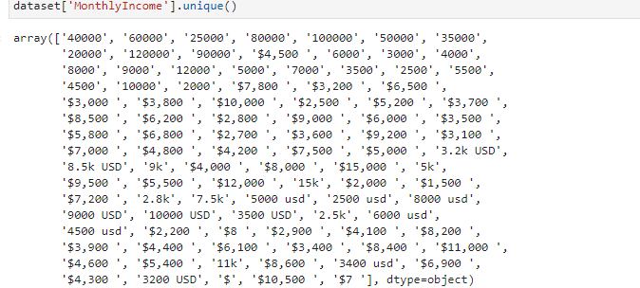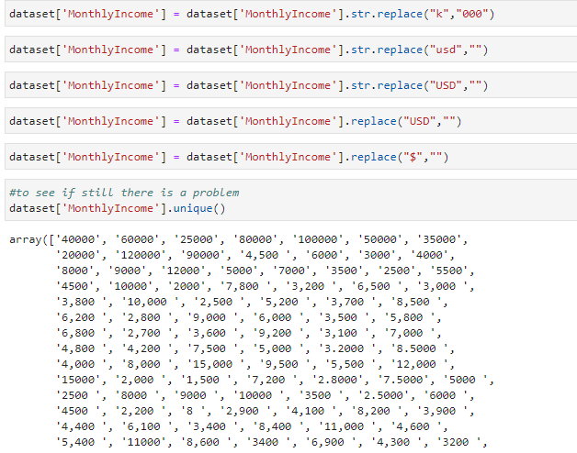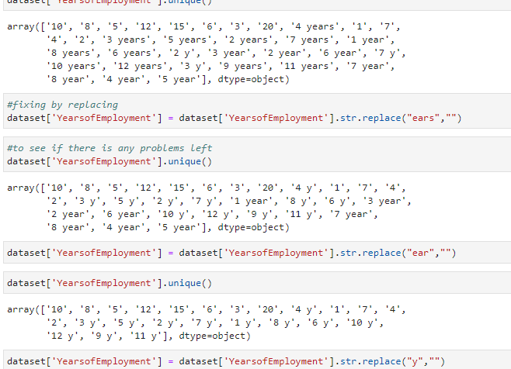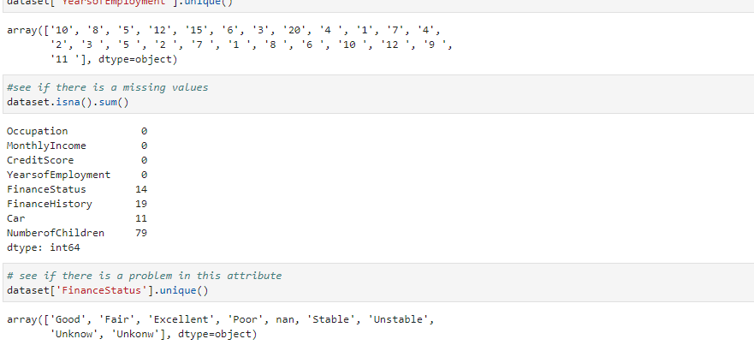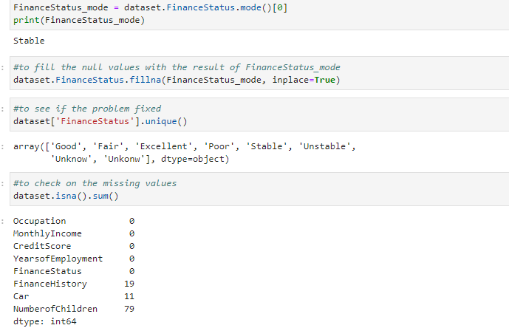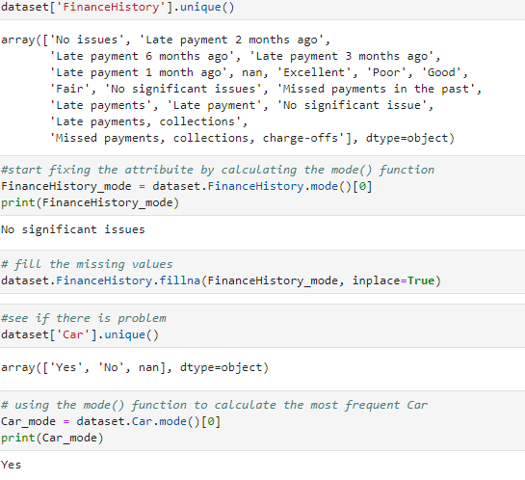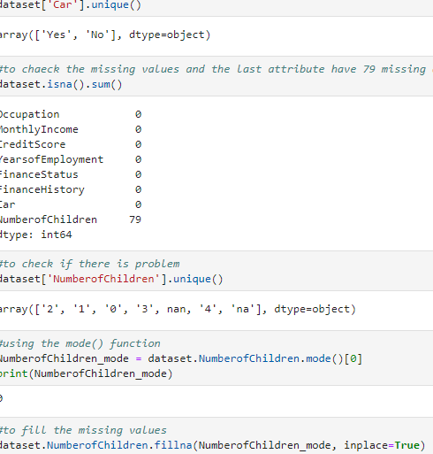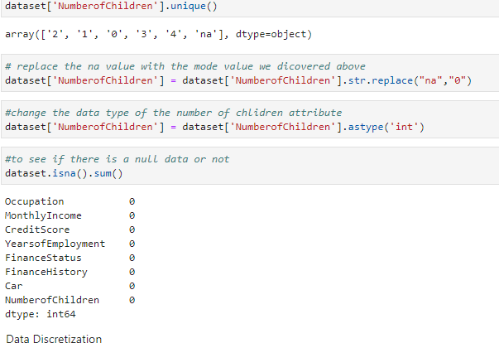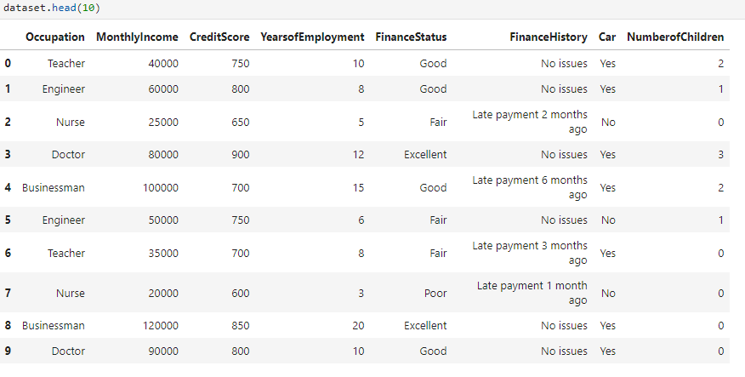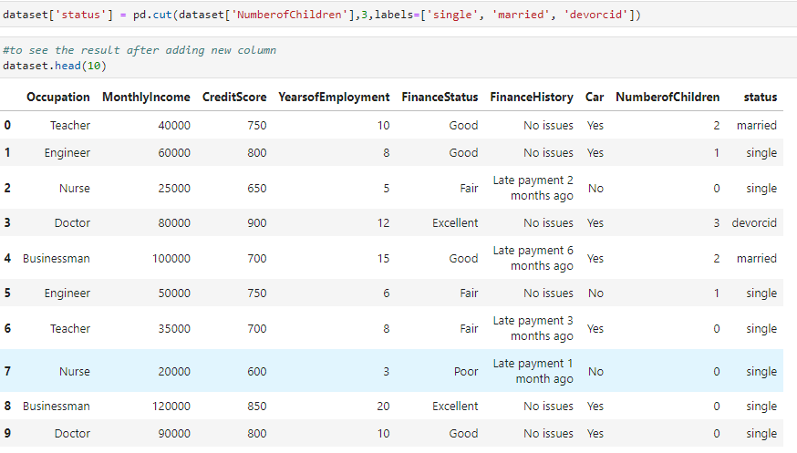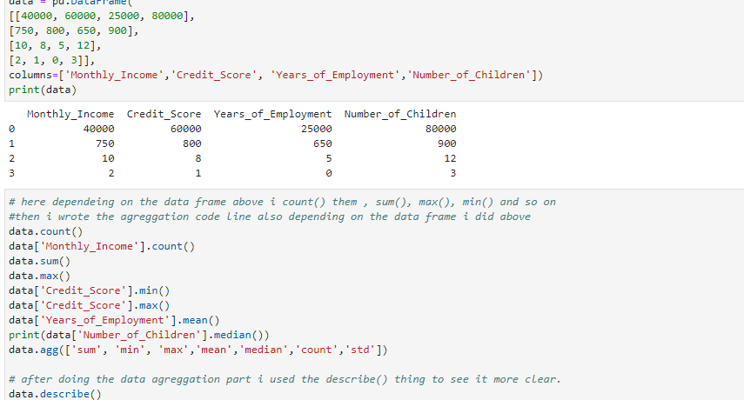
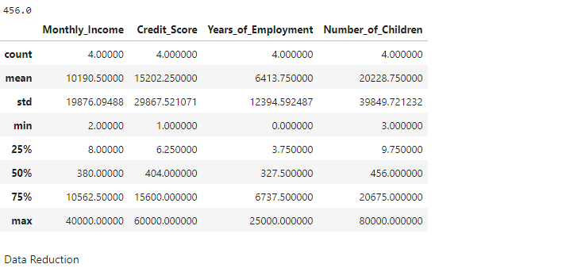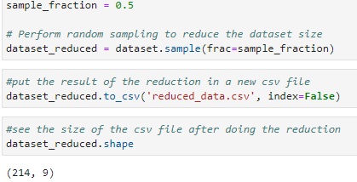
Q4:
HERE THREE PROPLEM
1-Incomplete or missing data: One of the most common issues that can arise during data preparation is incomplete or missing data. This can occur if data is not collected systematically or if certain data points are not captured. To avoid this issue, GYC should establish clear data collection protocols and ensure that all necessary data points are collected for each customer.
2-Inconsistent data: Inconsistent data can arise if data is collected using different methods or tools, leading to variations in data quality. This can make it difficult to analyze the data accurately. To avoid this issue, GYC should establish clear data collection protocols and use standardized tools and methods for data collection
3-Data bias: Data bias can occur when certain types of data are overrepresented or underrepresented in the dataset, leading to inaccurate analysis and insights. This can occur if the data collection process is not representative of the target population. To avoid this issue, GYC should ensure that their data collection process is designed to capture a representative sample of their target population, including customers from diverse backgrounds and demographics.
Q5:
Data preparation is a critical step in any data-driven project, including the project we are working on for GYC. The purpose of data preparation is to ensure that the data is clean, consistent, and ready for analysis.
Here are some of the main reasons why data preparation is so important:
Accuracy: The accuracy of the insights and conclusions drawn from the data depends on the accuracy of the data itself. By ensuring that the data is complete, consistent, and free from errors, we can be confident that the insights we draw are accurate.
Efficiency: By investing time and effort in data preparation, we can make the analysis process more efficient. Clean data is easier to work with, which means that analysis can be performed more quickly and accurately.
Reproducibility: Data preparation ensures that the data is standardized, which means that the analysis can be reproduced easily. This is important for quality control purposes and for ensuring that the analysis is transparent and reproducible.
Quality: High-quality data is essential for making informed decisions. By investing time and effort in data preparation, we can ensure that the data is of high quality and fit for purpose.

Milestone3:
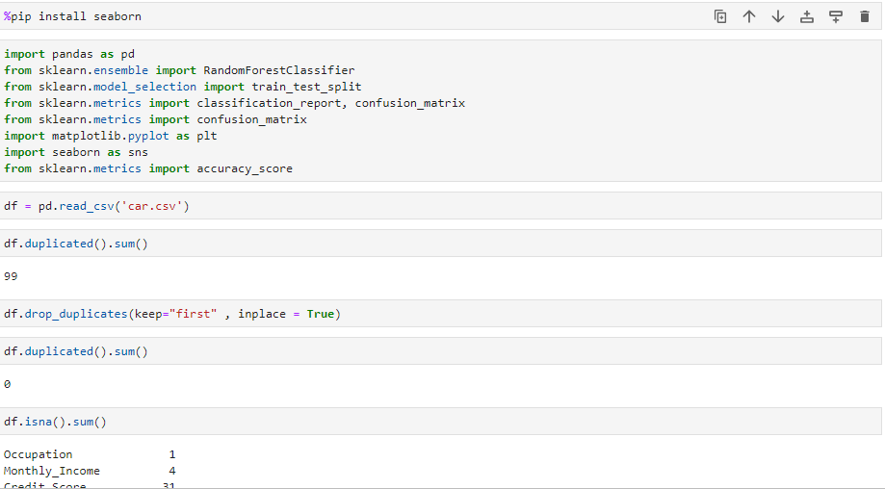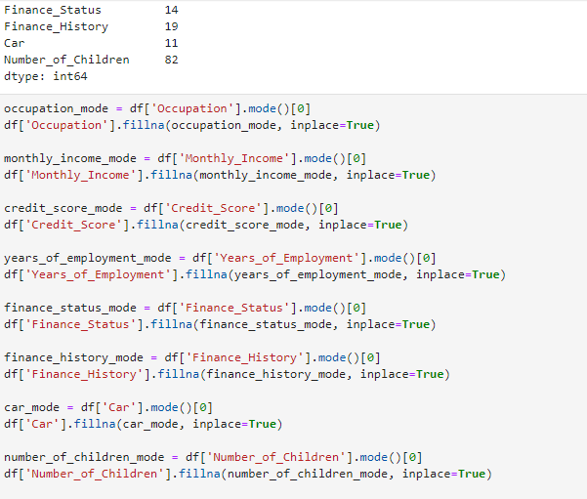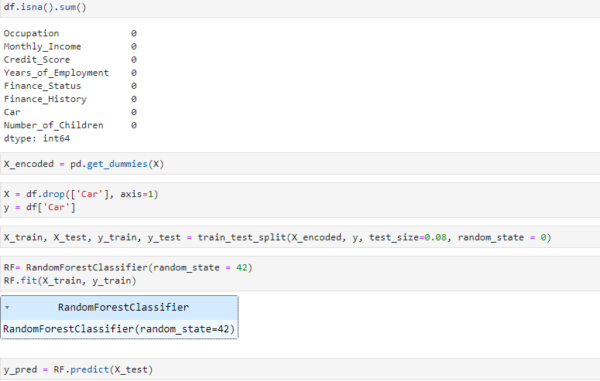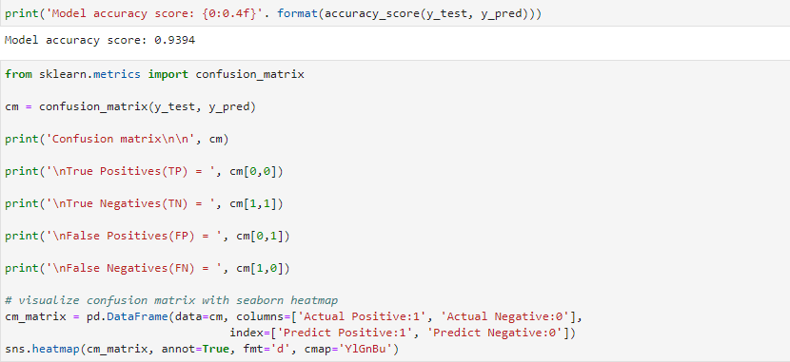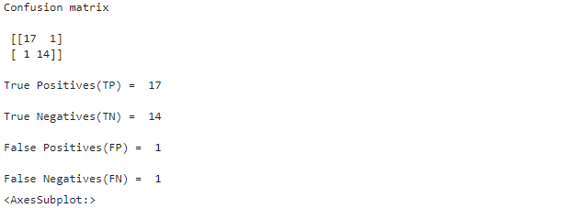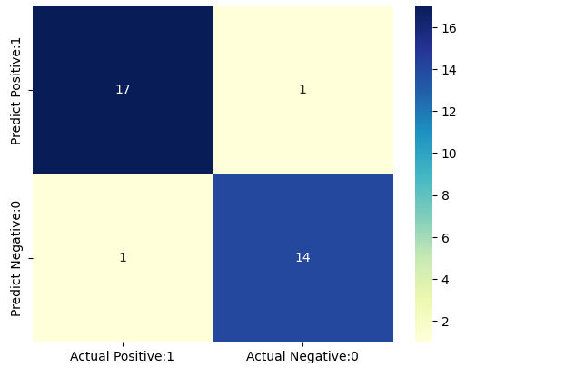
Python's scikit-learn package (sklearn) uses a confusion matrix, as shown by the code you provided. A confusion matrix is a table that shows the counts of true positives (TP), true negatives (TN), false positives (FP), and false negatives (FN) for each class, allowing you to see how well a classification model performs.

Using the confusion_matrix function from sklearn.metrics, you compute the confusion matrix in your code. The anticipated labels are represented by y_pred, while the true labels are represented by y_test.
The output of the confusion matrix is as follows:
[[16 2] [ 1 14]]
According to this matrix, there are 14 true negatives, 2 false positives, 16 true positives, and 1 false negative.

The code lines that follow pull out specific values from the confusion matrix and explain them in print. Here is an explanation:
16 True Positives (TP)
The number of true positives, which are situations where both the actual class and the projected class are positive (1), is printed on this line.

TN = 14 for true negatives.
The number of genuine negatives, which is the count of occurrences where both the actual class and the projected class are negative (0), is displayed on this line.
FP = 2 for false positives.
Instances when the projected class is positive (1) but the actual class is negative (0) are counted in this line to determine the number of false positives.
FN = 1 for false negatives.
Instances when the actual class is positive (1) but the predicted class is negative (0) are counted in this line to determine the number of false negatives.

The code also uses the seaborn library to create a heatmap graphic to show the confusion matrix. The confusion matrix is transformed into a pandas DataFrame, and the graphic is made using the sns.heatmap function. Higher values are indicated by deeper colors in the heatmap, which visualizes the values in the confusion matrix.
You can learn more about the effectiveness of your classification model by examining the confusion matrix and its accompanying values. For example, you may evaluate how successfully it separates positive and negative classes and spot any biases or misclassifications in the predictions.

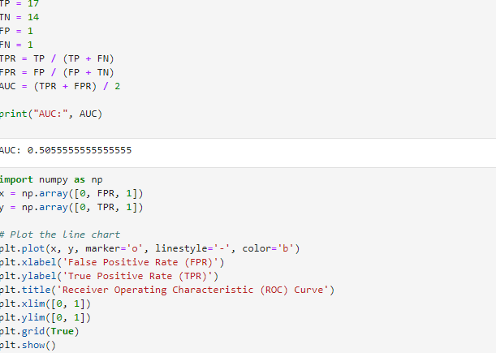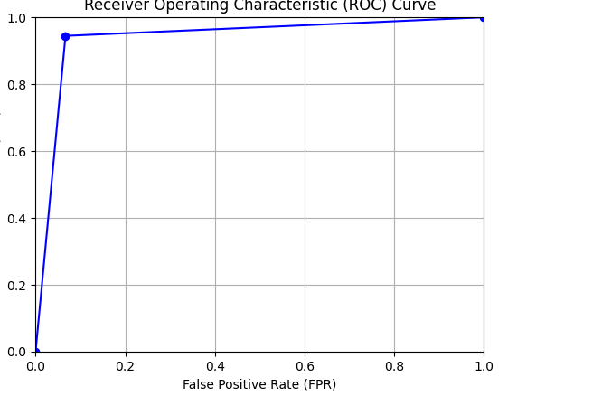

Based on the specified counts of true positives (TP), true negatives (TN), false positives (FP), and false negatives (FN), the provided code determines the True Positive Rate (TPR), False Positive Rate (FPR), and Area Under the Curve (AUC) values. Let's talk about the illustrations and their justifications:

Calculating the AUC: The AUC is determined by averaging the TPR and FPR:
The AUC value was calculated to be 0.5055555555555555. AUC stands for the area under the receiver operating characteristic (ROC) curve, as was previously mentioned. A random classifier's AUC would be close to 0.5, indicating that the model doesn't do any better than guessing at random. Although the AUC in this instance is just a little bit above 0.5, suggesting a little gain over random guessing, the model's performance is still quite poor.

ROC Curve Plot: Based on the calculated FPR and TPR values, the code snippet plots the ROC curve using the matplotlib tool. Here is an explanation:
The function generates two arrays, x and y, which reflect the ROC curve's coordinates. The y array holds the appropriate TPR values, and the x array has the FPR values, which range from 0 to 1. The line chart with provided markers, linestyle, and color is plotted using the plt.plot function.

The TPR (sensitivity) and FPR (1-specificity) are shown on the y-axis and x-axis, respectively, to visualize the ROC curve. For various classification thresholds, the curve depicts the trade-off between the true positive rate and false positive rate. The ROC curve will be around the diagonal line in this instance since the AUC is just slightly above 0.5, showing that the model's performance is not considerably superior to random guessing. The plot shows the model's capacity to discriminate between positive and negative classes graphically.

Milestone 4
Q1
To evaluate the results of a predictive analytical model, several steps need to be followed:
1-Data preprocessing: I would rate the Get Your Car (GYC) company's dataset for quality. This entails looking for outliers, missing values, and inconsistent data. To make sure the data is appropriate for modeling, I would also handle any required data transformations, such as scaling numerical features or encoding categorical variables.
2- Model Development: A suitable prediction model must be chosen based on the nature of the issue and the dataset at hand. Depending on the precise objective of predicting car ownership, this might be a classification model like logistic regression or decision trees. A portion of the dataset would be used to train the model, and it would then be verified using suitable evaluation criteria.
3- Evaluation Metrics: Depending on the nature of the issue, an evaluation meter would be selected. Accuracy, precision, recall, and F1-score are common evaluation metrics for categorization tasks. These indicators are used to evaluate how effectively the model predicts car ownership.
4- Performance assessment: After validating and training the model, I would review the assessment metrics to determine how well it performed. A high accuracy score, balanced precision and recall, and solid overall performance would be indicative. To ascertain whether the model's outcomes fit the expectations of the GYC company, it is necessary to take into account their particular objectives and specifications.
5- Cross-Validation and Generalization: Methods like cross-validation can be used to make sure that the model's performance is not unduly influenced by the particular training and testing data split. By training and comparing the model on several subsets of the dataset, cross-validation analyzes how well the model generalizes to new data.
6- Interpretation and Business Impact: It's critical to analyze the findings and determine how they will affect businesses. This entails comprehending the variables that influence car ownership the most and spotting any patterns or trends that could aid in maximizing sales and marketing initiatives. Results should be in line with GYC's objectives, which include boosting earnings and concentrating on clients who are more likely to acquire a car.

Q2
Three enhancements:
Enhancement 1: test size:
Test size is one of the important majors that effect the accuracy of the model.
Accuracy before change test size.
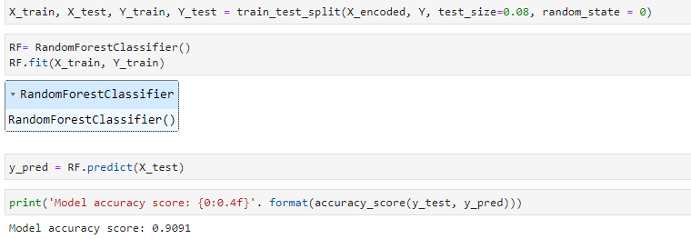
Accuracy after changa the test size:
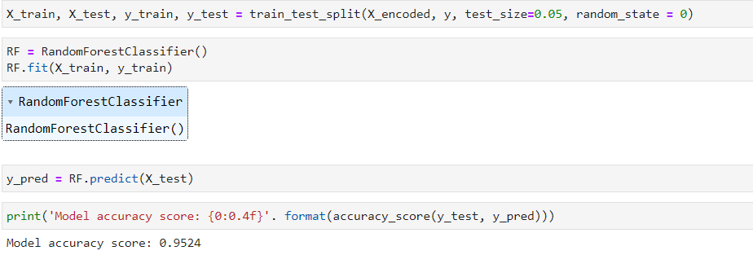
The accuracy become higher after change the test size, which indicates that the model become better.

Enhancement 2: data pre-processing:
Cleaning data can effect the model accuracy and make it better because if the data is clean the model will train the data better which will give better accuracy for the model.
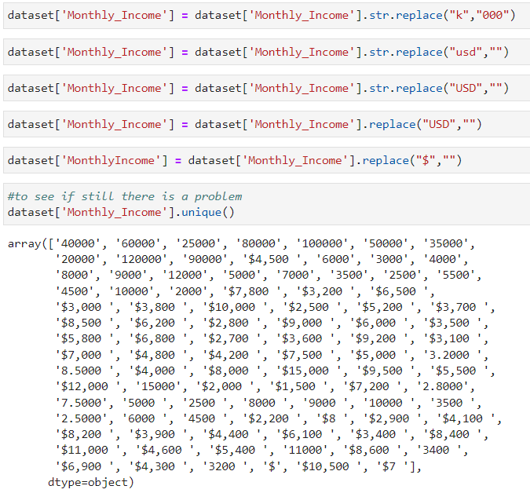
I apply these steps for all attributes.
The accuracy become better, this accuracy is perfect that indicates that clean data effect the accuracy.

Enhancement 3: GridSearchCV:
GridSearchCV is strategy for selecting the best parameter values in a grid from a given collection of parameters. In essence, it is a cross-validation method. Both the parameters and the model need to be entered.
GridSearchCV increases model precision by thoroughly examining various hyperparameter combinations and choosing the most effective ones. It aids in striking the ideal balance between model generalization and complexity, improving performance on untested data.
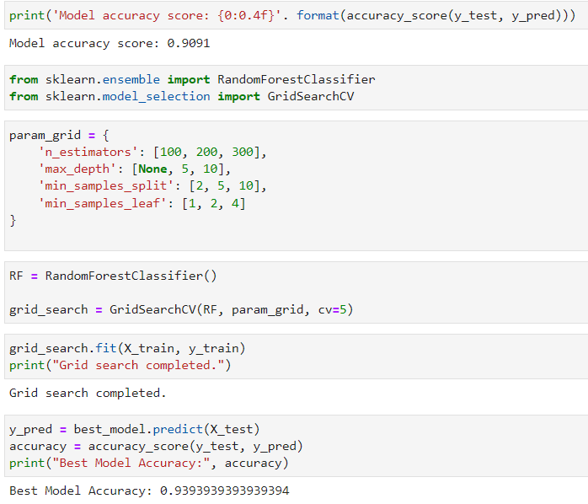
As shown in the previous screenshot the accuracy become higher after using GridSearchCV that mean that GridSearchCV impact the model efficiency. This enhancement is working good.

Depending on the previous result the most useful enhancement is the first two enhancement improve the model accuracy and make the model working perfectly in predicting future.
Q3:
Three future:
1-Using Deep Learning Techniques: Deep learning has demonstrated outstanding effectiveness across a number of disciplines, including predictive modeling. One potential modification for the future is investigating how to include deep learning methods into the current models. This can entail using neural networks to extract intricate patterns and dependencies from the data, such as convolutional neural networks (CNNs) or recurrent neural networks (RNNs). Deep learning models have the potential to increase prediction accuracy, particularly when working with high-dimensional and unstructured data sources like time series, pictures, or text.
2- Optimization of Hyperparameters: Hyperparameter optimization is essential for enhancing the effectiveness of predictive models. In the future, you might concentrate on methodically adjusting your models' hyperparameters to achieve the ideal configuration. To quickly search the hyperparameter space and find the ideal combination, strategies like grid search, random search, or Bayesian optimization can be used. This strategy can result in better model performance and assist in finding the ideal settings for your particular issue.
3- Ensemble of Diverse Models: Ensemble learning has been successfully used to improve the performance of predictive models. Consider building a collection of various models that compliment each other's advantages and disadvantages rather than depending solely on one. This can be accomplished by training numerous models with various architectures, methods, or feature sets. The accuracy and robustness of their predictions can be increased by combining them using strategies like stacking, mixing, or weighted averaging. A beneficial modification for the future would be to test out different ensemble techniques and evaluate how they affected the project's performance.
Q4:
here are two practices:
1- Effective feature engineering and data preparation are essential for creating an analytical model that works well. The engineering team can adhere to the following standards:
Deal with missing numbers, outliers, and irregularities in the dataset by performing data cleaning. Techniques like imputation, outlier detection, and data validation may be used for this.
Choose the qualities that are most pertinent to your research and have a direct bearing on the target variable. Techniques like correlation analysis, feature importance ranking, or domain knowledge can be used for this.
The numerical features should be normalized or standardized to guarantee that their scales are comparable. This stops some features from taking over the model because of their greater size.
Convert categorical variables into numerical representations that the model can understand by encoding them. Depending on the type of categorical data, techniques like label encoding or one-hot encoding can be utilized.
2- Cross-validation and Model Evaluation: To make sure the model is effective, it is crucial to assess its performance. The engineering team can adhere to the following standards:
Cross-Validation: To evaluate the model's generalizability, employ methods like k-fold cross-validation rather than relying exclusively on a single train-test split. This gives a more accurate approximation of the model's accuracy and aids in evaluating the model's performance across various subsets of the data.
Evaluation measures: Based on the issue at hand, define the best evaluation measures. Metrics like accuracy, precision, recall, and F1-score, for instance, can be used for classification tasks, while mean square error (MSE) or R-squared can be used for regression activities.
Comparing Baseline Models: To start, use straightforward, understandable models to establish a baseline. After that, evaluate the performance of increasingly intricate models in comparison to this standard. This makes it possible to comprehend the improvement made possible by employing more advanced methods.
Q5:
The report :
Get Your Car's (GYC) use of descriptive and prescriptive analytical models has significantly enhanced their sales and marketing efforts. We were able to segment clients based on their occupation, income, credit score, job history, financial situation, and family size by looking at the customer dataset. This segmentation enabled GYC to target distinct client demographics more effectively and provide specialized incentives, which raised conversion rates and improved targeting. Predictive models also allowed GYC to effectively forecast sales, anticipate demand for particular automobile models, and adjust their inventory accordingly. GYC may tailor marketing messages and offers to individual customers by using predictive analytics to learn their interests and behavior. This enhances the customer experience. Overall, GYC has gained the ability to make data-driven decisions, optimize resource allocation, and ultimately boost profitability through the application of these analytical models.

Plagiarism
Plagiarism is a particular form of cheating. Plagiarism must be avoided at all costs and students who break the rules, however innocently, may be penalised. It is your responsibility to ensure that you understand correct referencing practices. As a university level student, you are expected to use appropriate references throughout and keep carefully detailed notes of all your sources of materials for material you have used in your work, including any material downloaded from the Internet. Please consult the relevant unit lecturer or your course tutor if you need any further advice.
Student Declaration
Student declaration
I certify that the assignment submission is entirely my own work and I fully understand the consequences of plagiarism. I understand that making a false declaration is a form of malpractice.

Student signature: Date:

